Hearing Status of the Jackson Heart Study Cohort
National Institutes of Health, Institute on Deafness and Communicative Disorders:
5-RO1-DC008371-01

Principle Investigator: John M. Schweinfurth, M.D.
Document Prepared by Charles E. Bishop, Au.D., Ph.D.

DESCRIPTION OF STUDY
The study protocol was approved by the institutional review boards of the participating institutions: the University of Mississippi Medical Center, Jackson State University, and Tougaloo College. All of the participants provided written informed consent.
Data collection commenced in January 2008 and continued for 7 years (initial 5 years and two 1- year no-cost extensions). All assessments of participants were performed by a Mississippi state licensed audiologist.
The individuals who were enrolled in the hearing study were volunteers on days when they were undergoing other tests for the JHS. Therefore, our dataset represents a convenience sample of “healthy” volunteers.
The total number of participants with complete auditory data on file is 1322. However, not all of these participants have correct JHS ID’s (approximately 50-100). So, their auditory data cannot be linked to non-auditory JHS variables (such as waist circumference) and have, therefore, been removed from the published dataset until the correct ID’s can be obtained. There are an additional 100 participants whose data are still in paper form. These will be added to the full dataset soon.
Those participants who presented with contraindications for testing, such as active ear infections or occluding cerumen in the external ear canals, were assessed post medical clearance. Nonetheless, some individuals exhibited abnormal middle ear compliance/pressure as evidenced by tympanometry and some exhibited this as well as a significant air-bone gap, despite not having active middle ear disease. These individuals are included in the dataset, but are few.
COLLECTION OF DATA
All auditory data were collected from JHS participants during their routine visits to the JHS facility, as described above. All testing was performed within a 30 minute time frame, based on our protocol as approved by the NIH. Payment to each participant was $20. Missing data fields are typically the result of the inability to obtain a measurement due to: equipment malfunction, time constraints in the testing situation, or individual refusal to participate. All data were entered into spreadsheet manually by clinician/investigators. All data entry were double checked for accuracy by a study co-investigator.
History/Questionnaires
After signing informed consent, each participant was given a 9-item binary (YES/NO) “hearing health” questionnaire (see data dictionary). Individuals who answered YES to any question 1-4 (1=Hearing Problem, 2=Noise Exposure, 3=Tinnitus, 4=Vertigo/Dizziness) were given an additional questionnaire. For example, Q3 is “Do you have tinnitus (ringing in the ears).” Individuals who answered YES were then given the Tinnitus Handicap Inventory (THI), and so on. The only “standardized” questionnaires that were given to participants are the Hearing Handicap Inventory for the Elderly (HHIE; Ventry and Weinstein, 1982) and the THI (Newman, et al., 1996). The vertigo/dizziness questionnaire represents a list of questions that are descriptive in nature. This is the same for the tinnitus questionnaire. Information regarding the scoring of the HHIE-S and the THI, as well as the coding of responses for all of the questionnaires is apparent from the worksheets (see attached).
Audiometry and Tympanometry
Audiometry was performed with insert earphones (ER-3A type, GN Otometrics, Denmark) on a two channel diagnostic audiometer (Madsen Conera, GN Otometrics, Schaumburg, IL), calibrated yearly to ANSI (American National Standards Institute) specifications for diagnostic audiometers (ANSI, 1989). All participants were evaluated in a commercially available test room, which met the ANSI standards for permissible ambient noise (Frank, 2000). Assessment of middle ear compliance and pressure were assessed with a conventional tympanometer (Madsen Capella, GN Otometrics, Shaumberg, IL.; ANSI, 1991; Wiley, et al., 1996). All audiometric testing was performed in accordance with procedures recommended by the American Speech-Language-Hearing Association (ASHA, 1978). Thresholds were determined for octaves from 250 Hz to 8000 Hz by air conduction and for octaves from 500 Hz to 4000 Hz by bone conduction.
Speech audiometry included speech reception/recognition threshold (SRT) only. This was essentially used as a method for cross-checking pure tone audiometric reliability. Word recognition was not assessed due to time constraints and research design.
Auditory Processing
As mentioned above, due to time constraints, some tests could not be performed (such as word recognition) in favor of other tests thought to be more valuable.
Quick Speech-in-Noise Test
Because of its relative ease of administration and high accuracy, the Quick Speech in Noise test (QuickSIN; Etymotic Research, Elk Grove, IL), an adaptive SNR test, was chosen for use in the JHS hearing study. The QuickSIN was administered to the right and left ears with speech and noise delivered ipsilaterally. Unless the participant struggled with the task, this was not repeated. Two sentence lists were used for the study (see attached) and were randomly administered to the right and left ears for all participants. Presentation level for the QuickSIN was based on the recommended procedure, as described by the developers of the test. The data from the QuickSIN in the published dataset are SNR-Loss values (see formula on worksheet).
Dichotic Digits Test
The Dichotic Digits Test (DDT) has been shown to be sensitive to lesions of the brainstem, auditory cortex and corpus callosum and serves as a reliable screening tool for central auditory processing disorders. Normative data on the DDT are available (Musiek, et al., 1991). The test is usually presented at 50 dB SL (sensory level, i.e., the level above another measure) in reference to the spondee threshold (SRT). The reference can also be the pure-tone average or the 1000-Hz threshold, but the spondee threshold is preferred and was used in the JHS hearing evaluation study. For those with hearing loss, the test is presented at the most comfortable loudness level. Whether the test is presented at 20 dB SL or higher, the SL presentation is the same for each ear.
The DDT stimulus items were modified for use in this study. Both the single pair and double pair sub-tests were shortened to only 7 practice and 10 test items per sub-test. Additional practice was used for individuals who struggled with the task. The DDT was scored two different ways. Firstly, and as represented in the published dataset, the DDT score is based on the number/percentage of times a participant correctly identified all of the numbers presented (single pair or double pair of numbers). For example, if a participant missed only one of four numbers, then that item was scored as incorrect. The DDT was also scored such that a number/percentage was calculated for the absolute total number of items identified correctly, for the right and left ears. This is the procedure recommended by the developers of the test. Unfortunately, the data from this scoring method is not on the published dataset as two different clinician/investigators failed to score the DDT in this manner for portion of the participants, resulting in incomplete data.

Distortion Product Otoacoustic Emissions (DPOAEs)
DPOAEs were assessed with the Madsen Capella system (GN Otometrics, Schaumburg, IL), with the following stimulus parameters: L1= 60 dB SPL, L2 = 50 dB SPL, F2/F1 = 1.22 with F2 ranging from 1,000 to 8k Hz. The DPOAE measurement protocol used a sampling rate of 32,000 Hz. If a single-frame noise level exceeded 30 dB SPL, then that frame was rejected; similarly, if L1 or L2 differed by more than ±5 dB from the specified protocol level, then that frame was rejected. The f1 and f2 primary tone pair presentation were rejected if any of the following conditions occurred: (a) the presentation time exceeded16sec or 1,000 frames checked, (b) the noise level exceeded 250 frames or more, or (c) L1 or L2 were out of tolerance for 20 frames or more. Data are reported in the published dataset as absolute DPOAE value, and signal-to-noise ratio.

REFERENCES

American National Standards Institute (1989) Specification for Audiometers. New York, NY. ANSI S3.6.

American National Standards Institute (1991) Specifications for Instruments to Measure Aural Acoustic Impedance and Admittance (Aural Acoustic Admittance). New York, NY. ANSI S3.39.

American Speech-Language-Hearing Association (1978) Guidelines for Manual Pure-Tone Audiometry. ASHA, 20: 297.

Frank T (2000) ANSI update: Maximum permissible ambient noise levels for audiometric test rooms. Am J Audiol, 9: 3-8.

Newman CW, Jacobson GP, and Spitzer JB (1996) Development of the Tinnitus Handicap Inventory. Arch Otolaryngol Head Neck Surg, 122: 143-148.

Ventry IM and Weinstein BE (1982) The hearing handicap inventory for the elderly: a new tool. Ear Hear, 3(3): 128-34.

Wiley TL, Cruickshanks KJ, Nondahl DM, Tweed TS, Klein R, and Klein BE (1996) Tympanometric measures in older adults. J Am Acad Audiol, 7: 260-268.

Hearing Health Questionnaire
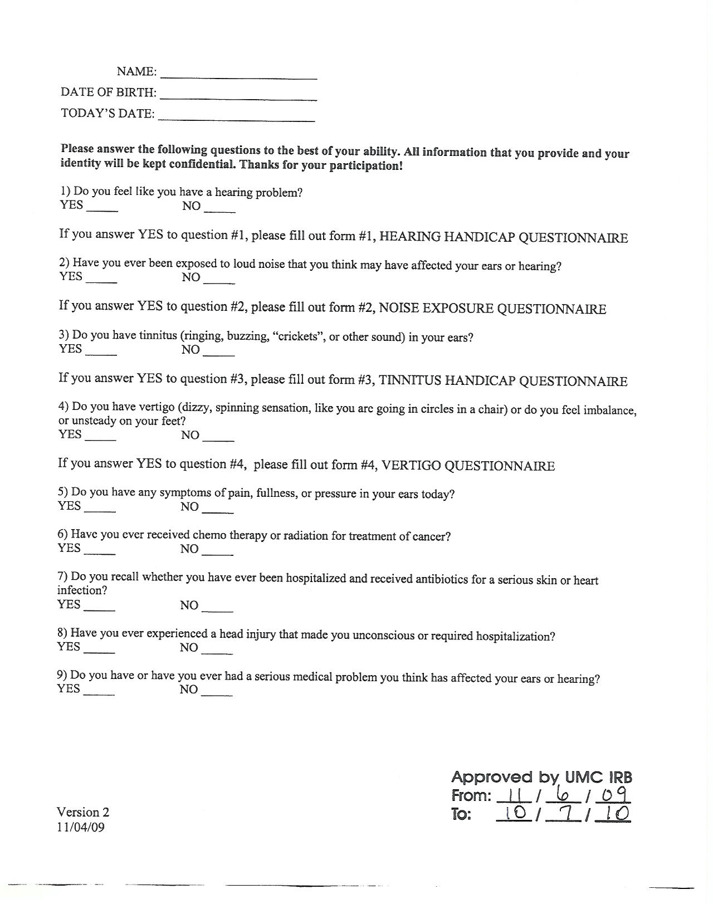

Hearing Handicap Inventory for the Elderly

Please answer yes, no or sometimes to each of the following questions. If you use a hearing aid, please answer the way you hear without the aid.

Does a hearing problem cause you to feel:

... embarrassed when you meet new people?

0 No 4 Yes 2 Sometimes

... frustrated when talking to members of your family?

0 No 4 Yes 2 Sometimes

Do you have difficulty hearing when someone speaks in a whisper?

0 No 4 Yes 2 Sometimes

Do you feel handicapped by a hearing problem?

0 No 4 Yes 2 Sometimes

Does a hearing problem cause you difficulty when visiting friends, relatives, or neighbors?

0 No 4 Yes 2 Sometimes

Does a hearing problem cause you to attend religious services less often than you would like?

0 No 4 Yes 2 Sometimes

Does a hearing problem cause you to have arguments with family members?

0 No 4 Yes 2 Sometimes

Does a hearing problem cause you difficulty when
listening to TV or radio?

0 No 4 Yes 2 Sometimes

Do you feel that any difficulty with your hearing limits or hampers your personal or social life?

0 No 4 Yes 2 Sometimes

Does a hearing problem cause you difficulty when in a restaurant with relatives or friends?

0 No 4 Yes 2 Sometimes

Total ‘No’ _______ X 0 = _______

Total ‘Yes’ _______ X 4 = _______

Total ‘Sometimes’ _______ X 2 = _______

Test Total _______

0 – 8 = No Handicap

10 – 24 = Mild to Moderate Handicap

26 – 4- = Severe Handicap

“Refer to physician if score is 10 or more”

Ventry IM and Weinstein BE (1982) The hearing handicap inventory for the elderly: a new tool. Ear Hear, 3(3): 128-34.

Noise Exposure Questionnaire

Have you ever experienced a temporary hearing loss from exposure to a loud noise?

0 [No] 0 [Yes, once or twice] 1 [Yes, many times] 9 [Unknown]

Have you ever experienced loud noise in your occupation?

0 [No] 0 [Yes, once or twice] 1 [Yes, many times] 9 [Unknown]

Have you ever shot a firearm without hearing protection?

0 [No] 0 [Yes, once or twice] 1 [Yes, many times] 9 [Unknown]

Do you think loud noise is responsible for any hearing loss or tinnitus that you may have?

0 [No] 1 [Yes} 9 [Unknown]

Do you operate loud machinery at home without hearing protection (such as lawn mowers, air blowers or tractors)?

0 [No] 0 [Yes, once or twice] 1 [Yes, many times] 9 [Unknown]

Do you listen to headphones (such as with a cell phone, walkman, portable radio or MP3 player)?

0 [No] 0 [Yes, once or twice] 1 [Yes, many times] 9 [Unknown]

Were you ever exposed to loud noise in the military?

0 [No] 0 [Yes, once or twice] 1 [Yes, many times] 9 [Unknown]

What best describes the kind of noise have you been exposed to the most?

0 [None] 6 [Constant, steady] 7 [Intermittent, sudden] 8 [Both] 9 [Unknown]

Tinnitus Handicap Inventory

Please circle the answer that best describes your tinnitus (noises in your ear).

Because of your tinnitus is it difficult for you to concentrate?

4 [YES] 0 [NO] 2 [SOMETIMES]

Does the loudness of your tinnitus make it difficult for you to hear people?

4 [YES] 0 [NO] 2 [SOMETIMES]

Does your tinnitus make you angry?

4 [YES] 0 [NO] 2 [SOMETIMES]

Does you tinnitus make you confused?

4 [YES] 0 [NO] 2 [SOMETIMES]

Because of your tinnitus, are you desperate?

4 [YES] 0 [NO] 2 [SOMETIMES]

Do you complain a great deal about your tinnitus?

4 [YES] 0 [NO] 2 [SOMETIMES]

Because of tinnitus, do you have trouble falling asleep at night?

4 [YES] 0 [NO] 2 [SOMETIMES]

Do you feel as though you cannot escape your tinnitus?

4 [YES] 0 [NO] 2 [SOMETIMES]

Does you tinnitus interfere with your ability to enjoy social activities (such as going out to dinner, to the cinema)?

4 [YES] 0 [NO] 2 [SOMETIMES]

Because of your tinnitus do you feel frustrated?

4 [YES] 0 [NO] 2 [SOMETIMES]

Does your tinnitus make it difficult to enjoy life?

4 [YES] 0 [NO] 2 [SOMETIMES]

Does your tinnitus interfere with your job or household responsibilities?

4 [YES] 0 [NO] 2 [SOMETIMES]

Because of your tinnitus, do you feel that you are often irritable?

4 [YES] 0 [NO] 2 [SOMETIMES]

Because of your tinnitus, do you find it difficult to read?

4 [YES] 0 [NO] 2 [SOMETIMES]

Does your tinnitus make you upset?

4 [YES] 0 [NO] 2 [SOMETIMES]

Do you feel that your tinnitus has placed stress on your relationships with your family and friends?

4 [YES] 0 [NO] 2 [SOMETIMES]

Do you find it difficult to focus your attention away from your tinnitus and on to other things?

4 [YES] 0 [NO] 2 [SOMETIMES]

Do you feel that you have no control over your tinnitus?

4 [YES] 0 [NO] 2 [SOMETIMES]

Because of your tinnitus, do you often feel tired?

4 [YES] 0 [NO] 2 [SOMETIMES]

Because of your tinnitus, do you often feel depressed?

4 [YES] 0 [NO] 2 [SOMETIMES]

Does your tinnitus make you feel anxious?

4 [YES] 0 [NO] 2 [SOMETIMES]

Do you feel that you can no longer cope with your tinnitus?

4 [YES] 0 [NO] 2 [SOMETIMES]

Does your tinnitus get worse when you are under stress?

4 [YES] 0 [NO] 2 [SOMETIMES]

Does your tinnitus make you feel insecure?
4 [YES] 0 [NO] 2 [SOMETIMES]
Total Score: _______________________

0 – 16 = Slight

18 – 36 = Mild

38 – 56 = Moderate

58 – 76 = Severe

78 – 100 = Catastrophic

McCombe, A., Bagueley, D., Coles, et al. (2001) Guidelines for the grading of tinnitus severity: the results of a working group commissioned by the British Association of Otolaryngologists, Head and Neck Surgeons, 1999. Clin Otolaryngol 26: 388-393.

Vertigo History Questionnaire

In the past year, have you experienced any sudden dizziness (NOT related to sudden changes in position)?

0 No 0 Yes, Once or Twice 1 Yes, All the Time 9 Unknown

In the past year, have you felt dizzy when rolling over in bed or when standing with your head tilted back, like you’re looking at the top shelf in a cupboard?

0 No 0 Yes, Once or Twice 1 Yes, All the Time 9 Unknown

When you are dizzy, do you:

 | No  [0] | Yes  [1] | Unknown  [9]
[LIGHT] Feel Lightheaded
[BLACK] Black out
[SWIM] Feel a swimming sensation in your head
[SEE] See objects spinning or turning about you
[HEADACHE] Have a headache
[NAUSEA] Experience nausea or vomiting
[DIPLOPIA] Have double or blurred vision
[PHOTOPSIA] See flashes of light
[SPIN] Feel like you're spinning

In the past year, have you had trouble keeping your balance when walking or standing with your eyes closed?

0 No 0 Yes, Once or Twice 1 Yes, All the Time 9 Unknown

In the past year, have you felt dizzy when standing up quickly?

0 No 0 Yes, Once or Twice 1 Yes, All the Time 9 Unknown

In the past year, have you felt dizzy when stepping out of a hot bath or shower?

0 No 0 Yes, Sometimes 1 Yes, All the Time 9 Unknown

QuickSIN Test Stimulus Items

Track 2 / List 1 Right or Left Pres. Level _________

- A white silk jacket goes with any shoes. S/N 25 __________
- The child crawled into the dense grass. S/N 20
__________
- Footprints showed the path he took up the beach. S/N 15 __________
- A vent near the edge brought in fresh air. S/N 10 __________
- It is a band of steel three inches wide. S/N 5 __________
- The weight of the package was seen on the high scale. S/N 0 __________

25.5 – TOTAL = ________SNR Loss TOTAL __________

Track 3 / List 2 Right or Left Pres. Level _________

- Tear a thin sheet from the yellow pad. S/N 25 __________
- A cruise in warm waters in a sleek yacht is fun. S/N 20 __________
- A streak of color ran down the left edge. S/N 15 __________
- It was done before the boy could see it. S/N 10 __________
- Crouch before you jump or miss the mark. S/N 5 __________
- The square peg will settle in the round hole. S/N 0 __________

25.5 – TOTAL = ________SNR Loss TOTAL __________

DDT Test Stimulus Items

Dichotic Digits/Track 4 Pres. Level _____________ Dichotic Digits/Track 5 Pres. Level ____________

Right Left Response Right Left Response

*1 3 ________ *41 68 ________
*4 8 ________ *58 43 ________
*8 1 ________ *39 65 ________
*3 5 ________ *45 81 ________
*2 4 ________ *26 39 ________
*5 2 ________ *64 12 ________
*4 3 ________ *49 86 ________
6 8 ________ 24 51 ________
5 4 ________ 52 49 ________
3 2 ________ 26 91 ________
5 9 ________ 85 26 ________
2 1 ________ 64 92 ________
1 6 ________ 95 13 ________
8 4 ________ 63 48 ________
2 9 ________ 68 32 ________
8 6 ________ 91 63 ________
6 5 ________ 56 18 ________

RAW SCORE _________ RAW SCORE _________ % SCORE _________ % SCORE _________
RAW SCORE = # CORRECT SRT: Right_________ MCL: Right ________
% SCORE = # CORRECT / TOTAL # ITEMS ( X 100)
* DENOTES PRACTICE ITEMS Left________ Left _______

